Ex.No: | DATA VISUALIZATION USING TABLEAU
Date:

AIM:
To connect, analyze, visualize, and create interactive dashboards using Tableau for effective business intelligence and data analytics.

ALGORITHM: Sleep and Lifestyle Visualization using Tableau
Step 1: Data Loading
- Connect the Sleep and Lifestyle dataset to Tableau.
- Verify the imported fields such as Person ID, Gender, Age, Occupation, Sleep Duration, Quality of Sleep, Physical Activity Level, Stress Level, BMI Category, Blood Pressure, Heart Rate, Daily Steps, and Sleep Disorder.
Step 2: Sleep Duration Bar Chart
- Create a worksheet for sleep duration analysis.
- Place Occupation on Columns.
- Place Sleep Duration on Rows.
- Select the Bar Chart visualization.
- Enable data labels to display the sleep duration values.
Step 3: Sleep Disorder Visualization
- Create a worksheet using Sleep Disorder and Person ID.
- Aggregate Person ID using COUNT.
- Visualize the distribution of sleep disorders using a Pie Chart.
- Display sleep disorder names and corresponding counts as labels.
Step 4: Sleep Performance Trend
- Create a Line Chart using Age and Sleep Duration.
- Place Age on Columns and Sleep Duration on Rows.
- Enable labels to display the values.
- Use the chart to observe the relationship between age and sleep duration.

Step 5: Sleep Quality Calculated Field
- Create a calculated field named Sleep Quality Percentage.
- Use the formula:
[Quality of Sleep] / 10 * 100
- Display the calculated percentage along with the relevant sleep-related fields.

Step 6: Occupation Filter
- Add Occupation to the Filters shelf.
- Select an occupation such as Software Engineer.
- Observe the updated sleep-related visualizations based on the selected occupation.
Step 7: Minimum Sleep Duration Parameter
- Create a parameter named Minimum Sleep Duration.
- Set the required minimum sleep duration value.
- Apply the parameter to display only people whose sleep duration meets or exceeds the selected value.
Step 8: Dashboard Creation
- Create a new Tableau Dashboard.
- Add the Sleep Duration, Sleep Disorder, Sleep Performance Trend, and Sleep Quality visualizations.
- Arrange the worksheets clearly.
- Add the Occupation filter and Minimum Sleep Duration parameter.
- Format the dashboard with suitable titles and labels.
Step 9: Story Creation
- Create a Tableau Story using the completed dashboard.
- Add story points for:
  - Overall Sleep Analysis
  - Sleep Disorder Analysis
  - Sleep Quality Analysis
  - Final Sleep and Lifestyle Analysis
- Present the visual insights using the story.
Step 10: Analysis
- Analyze the charts to identify differences in sleep duration and sleep quality.
- Compare sleep patterns among different occupations.
- Observe the distribution of sleep disorders.
- Observe how the Occupation filter and Minimum Sleep Duration parameter dynamically change the visualizations.
- Use the dashboard and story to summarize the overall sleep and lifestyle patterns.

OUTPUT:

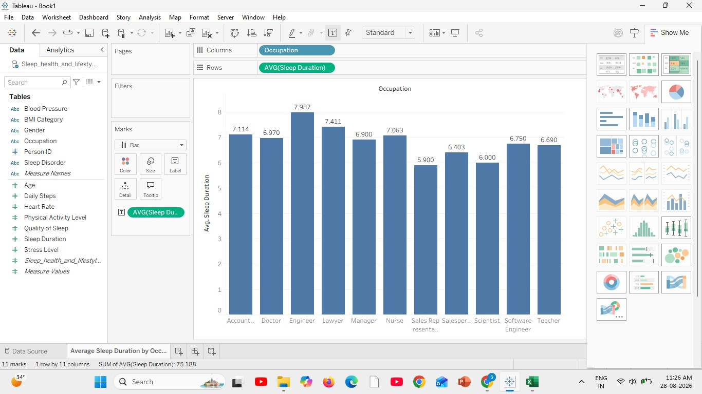
Bar Chart Creation:

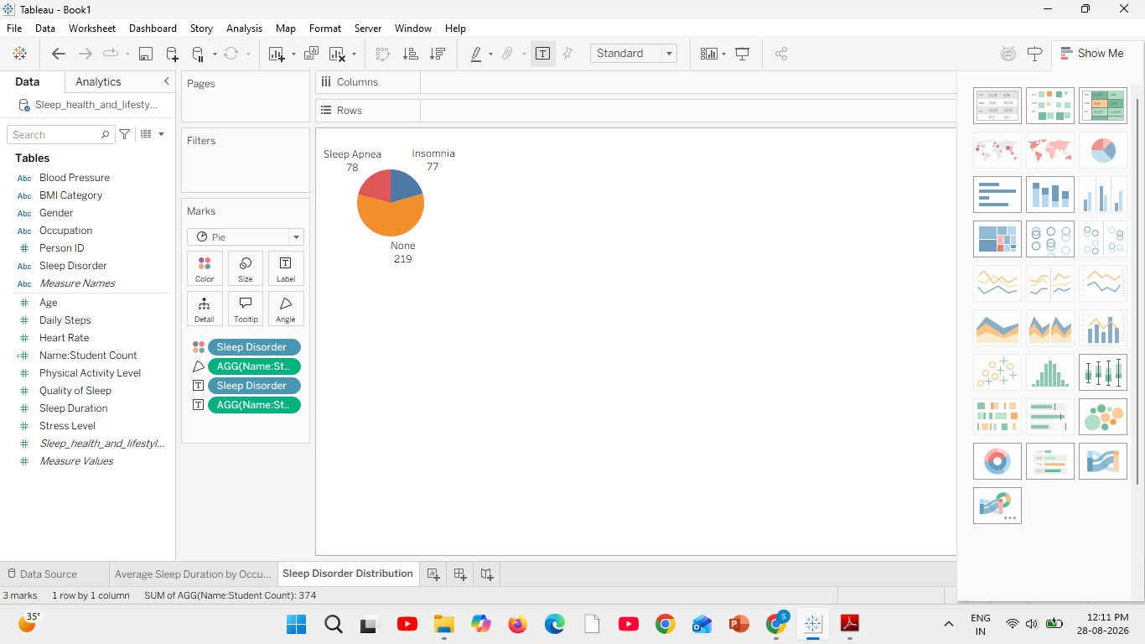
Pie Chart Creation:

Line Chart Creation:

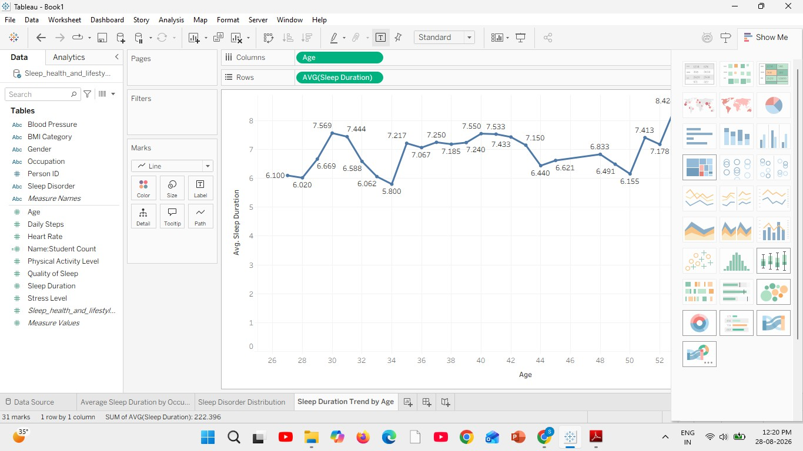

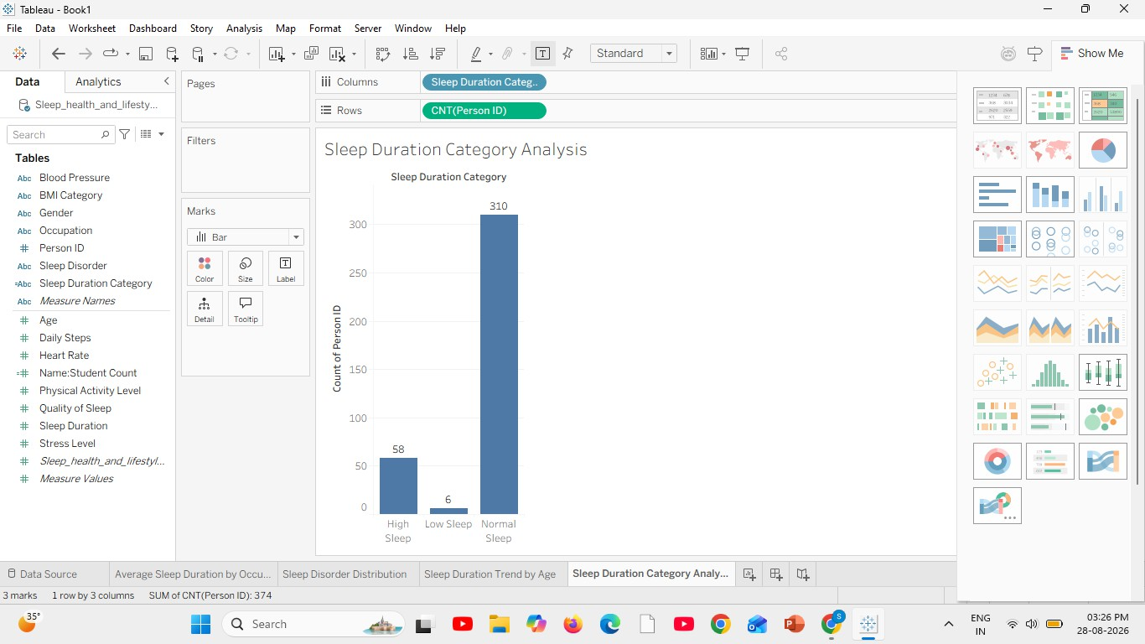
Creating Calculated Field:

Applying Filters:

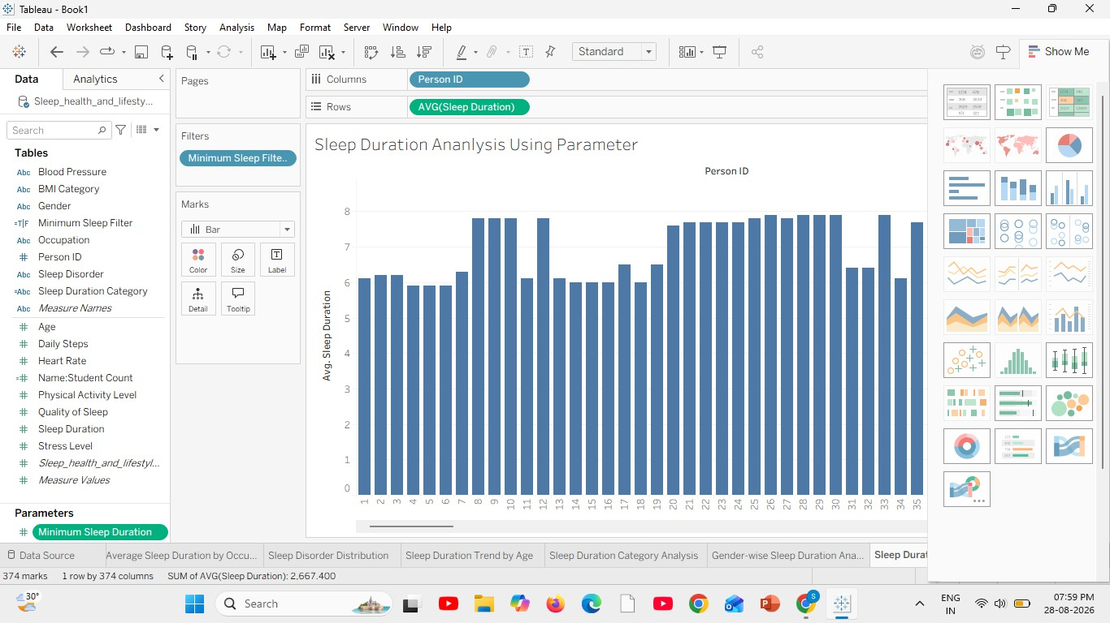

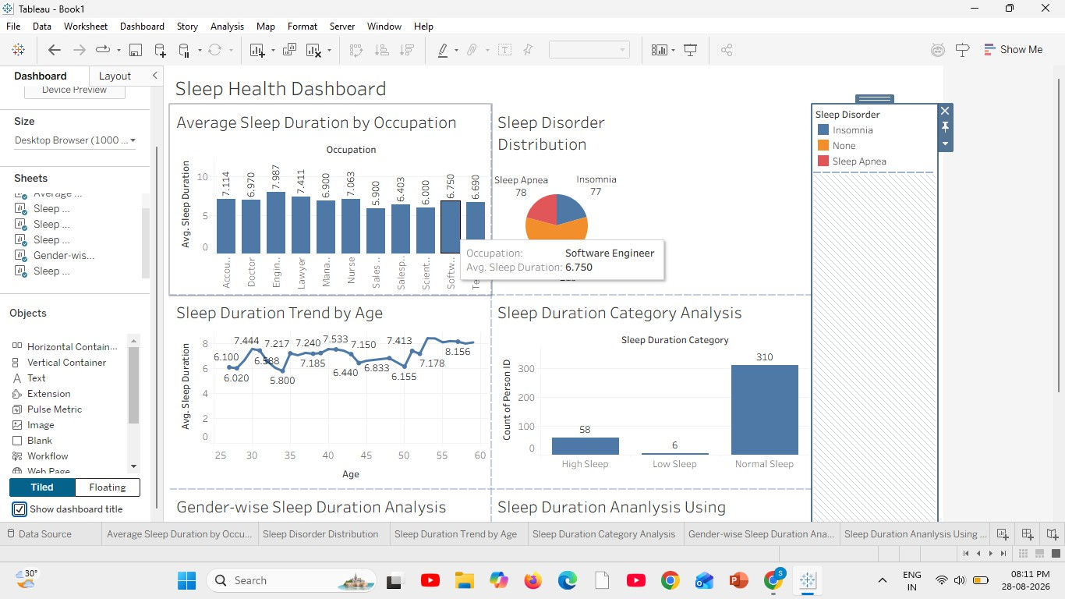
Dashboard Creation:

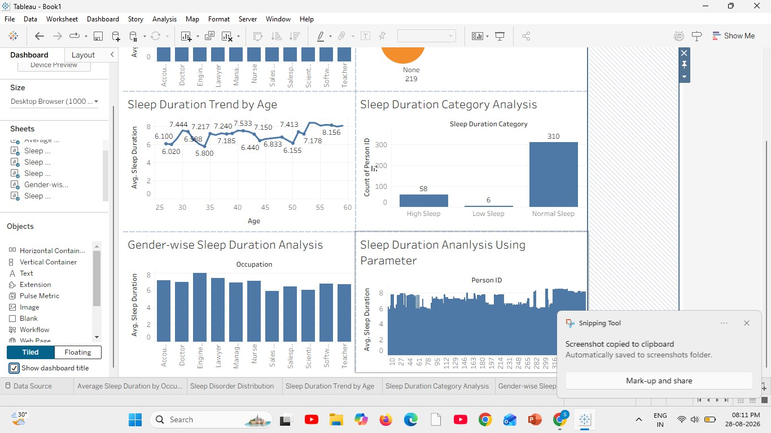

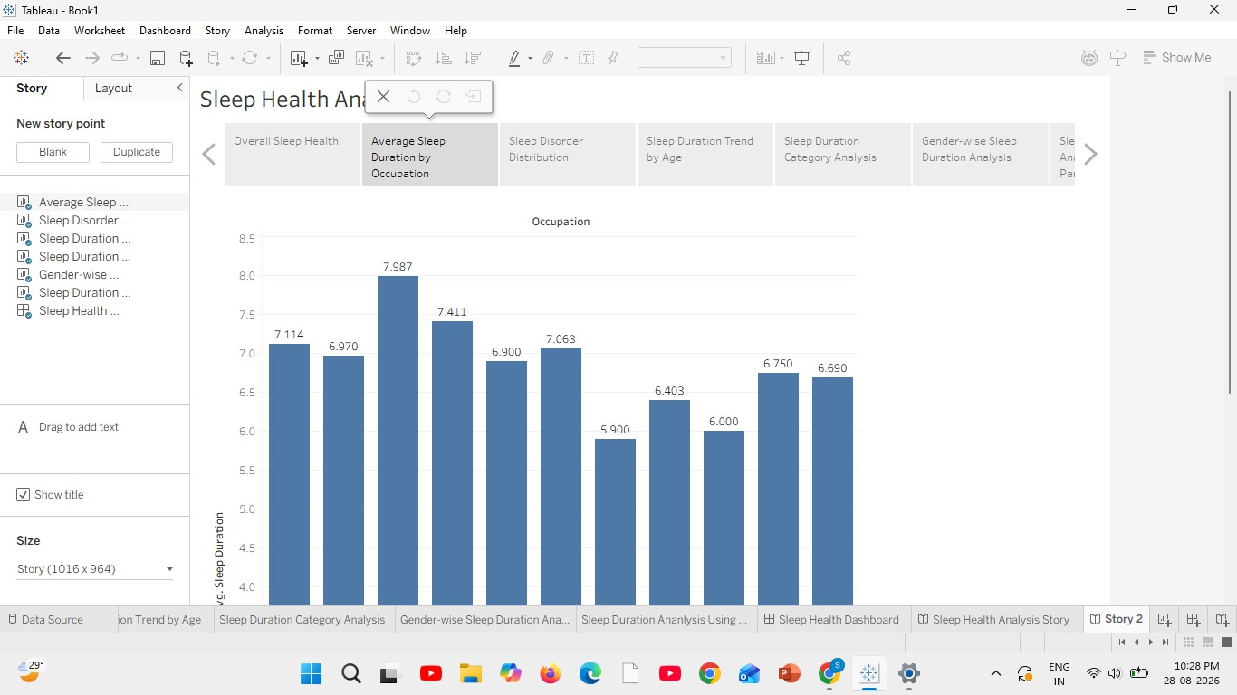
Story Creation:

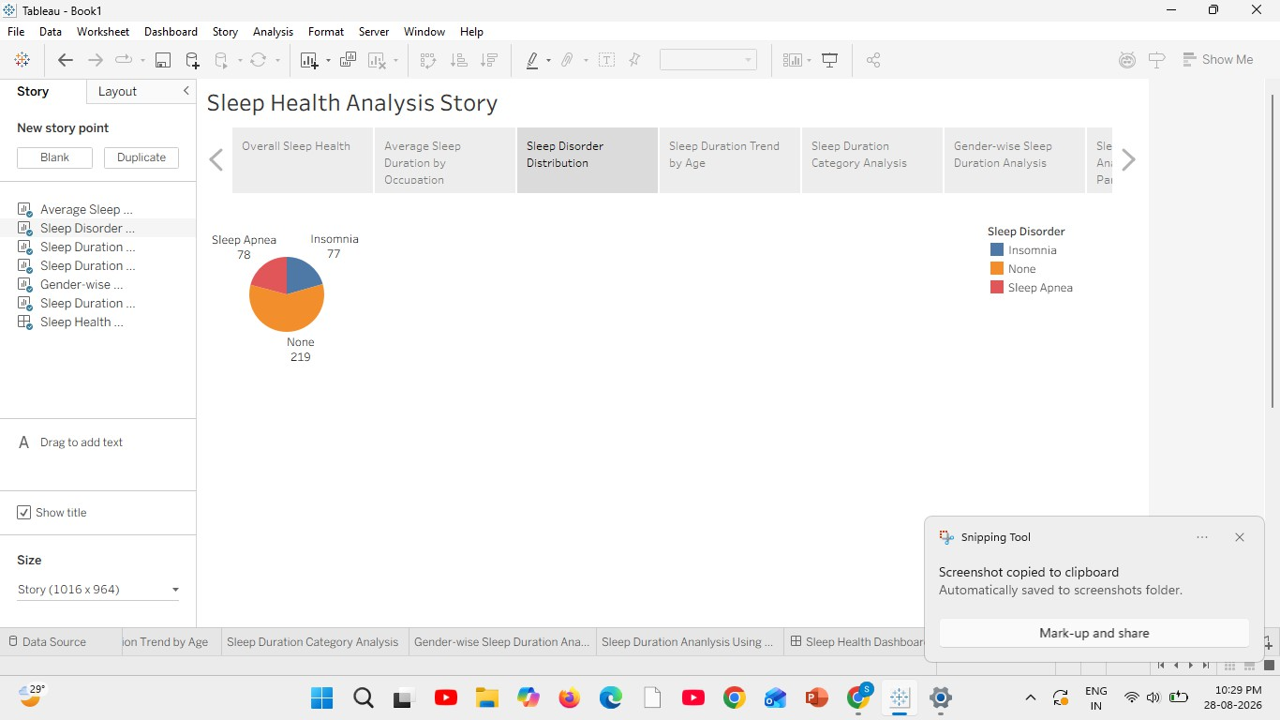
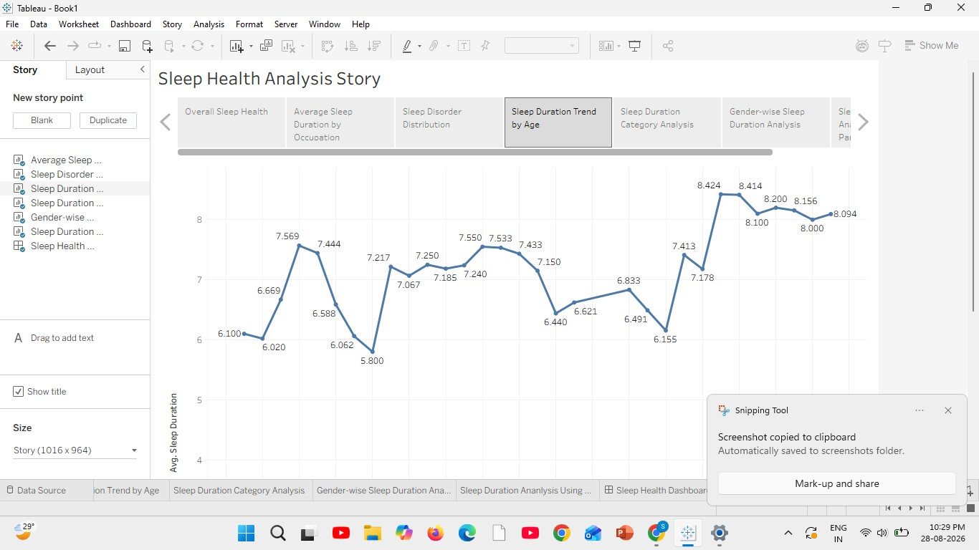

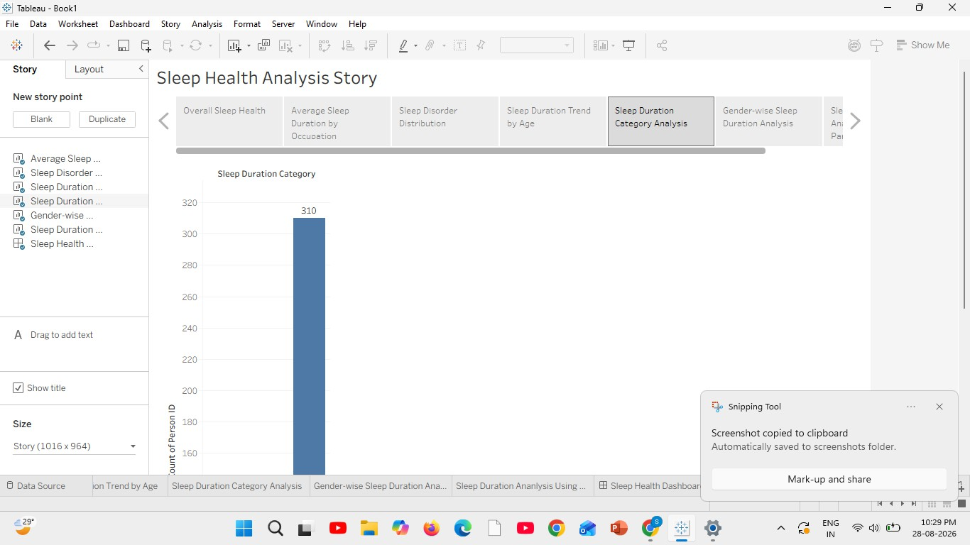
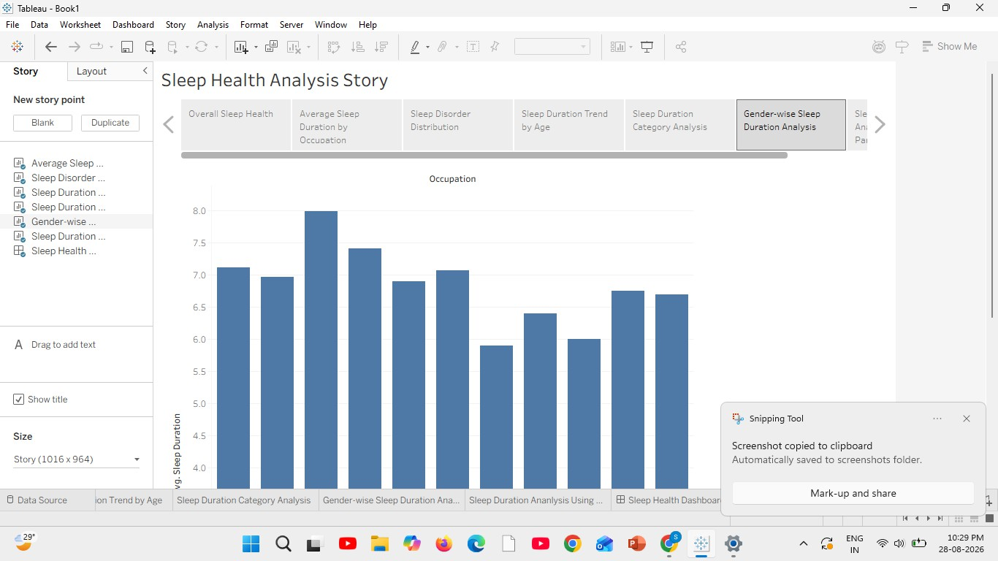

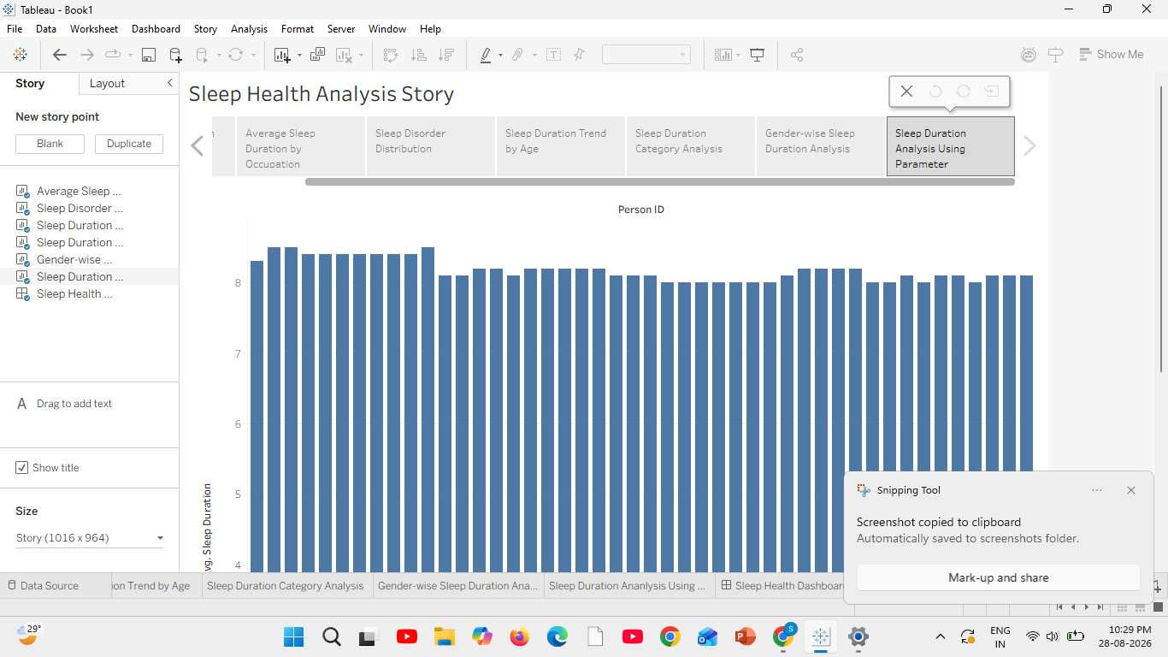

RESULT:

